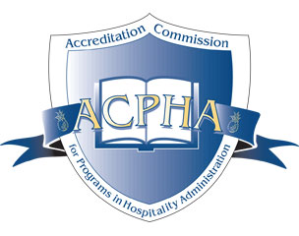
ACPHA ACCREDITATION COMMISSION
INTERNATIONAL PROGRAM READINESS REVIEW

Date:______________________________

To: Director
Accreditation Commission for Programs in Hospitality Administration (ACPHA)

To the best of my knowledge, this program complies with the Initial ACPHA Requirements for Programs in Hospitality/Tourism Administration per the Eligibility Requirement Policy, and we hereby apply for a:

- Readiness Review leading to initial accreditation application status
Enclosed is a check (non-refundable) for $1500.00 (International).

1. Name of institution: _______________________________________________

2. Name of program: ________________________________________________

3. Program Information:
Primary Contact (President/Provost/Rector/Dean):________________________
Program Primary Contact (Director/Faculty):_____________________________
Address/City/Country/Mail Code: _____________________________________ _________________________________________________________________
Phone: _______________________________________________________
Email: _________________________________________
Website Address Institution: ________________________________
Website Address Program: ________________________________

4. Date institution was authorized:

5. Type of control: (CIRCLE appropriate category)
Country
Province
Proprietary
Independent non-profit
City
Religious
Other (Specify) _____________________________________

Page 2

6. Name of the National/Government (Country of Applicant) or a recognized US-based regional/ institutional accrediting agency, which has already accredited the institution:

_____________________________________________________________________________

We will not make any promotional use of our intent to seek ACPHA accreditation prior to the actual review status by the Commission.

Program Director:

Signature:

School Official: Title:

Signature:

FOR ACPHA ADMINISTRATION USE ONLY:

Date Received_________
Reviewed for Readiness_________

